**Practical 1:**

**Simple & Display Statements:**

Q1.

#include<stdio.h>

void main()

{

clrscr();

printf(" HELLO C");

printf("\n Name: MANITA R JHA");

printf("\n Address: Mumbai");

}

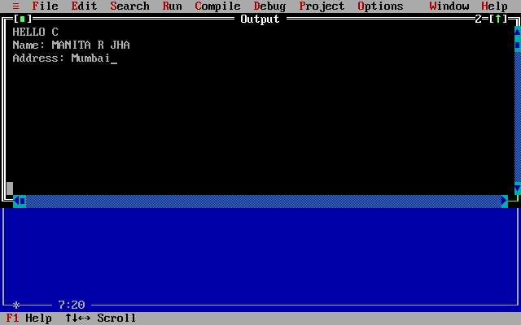

Q2.

#include<stdio.h>

void main()

{

clrscr();

printf("\t\t\t*");

printf("\n\t\t*\t\t*");

printf("\n\t*\t\t*\t\t*");

printf("\n*\t\t*\t\t*\t\t*");

}

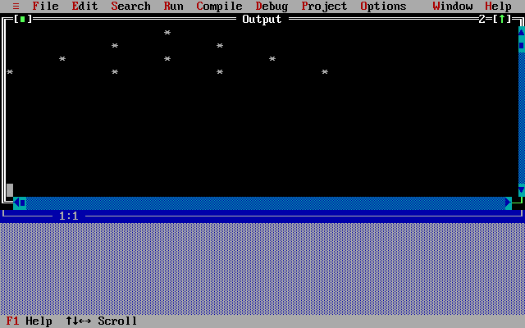

Q3.

#include<stdio.h>

void main()

{

clrscr();

printf("&");

printf("\n&\t&");

printf("\n&\t&\t&");

printf("\n&\t&\t&\t&");

printf("\n&\t&\t&\t&\t&");

}

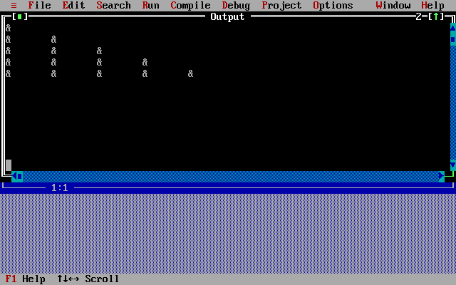

Q4.

#include<stdio.h>

#include<conio.h>

void main()

{

clrscr();

printf("\t\t\t\tA");

printf("\n\t\t\tB\tA\tB");

printf("\n\t\tC\tB\tA\tB\tC");

printf("\n\tD\tC\tB\tA\tB\tC\tD");

printf("\nE\tD\tC\tB\tA\tB\tC\tD\tE");

}

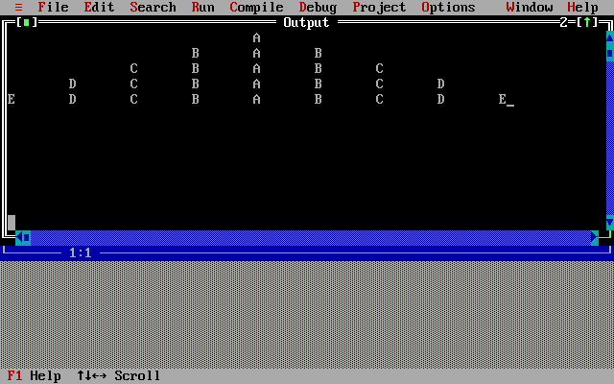

Q5.

#include<stdio.h>

#include<conio.h>

void main()

{

clrscr();

printf("*\t*\t*\t*\t*\t*\t*\t*\t*");

printf("\n\t*\t*\t*\t*\t*\t*\t*");

printf("\n\t\t*\t*\t*\t*\t*");

printf("\n\t\t\t*\t*\t*");

printf("\n\t\t\t\t*");

}

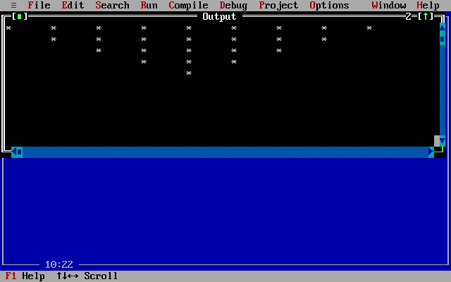

**Practical 2:**

**Operators:**

Q1.

//arithmetic operators

#include<stdio.h>

#include<conio.h>

void main()

{

int a,b,add,sub,mul,div,mod;

clrscr();

printf("Enter the value of a: ");

scanf("%d",&a);

printf("Enter the value of b: ");

scanf("%d",&b);

add=a+b;

printf("Addition of a,b is : %d",add);

sub=a-b;

printf("\nSubtraction of a,b is : %d",sub);

mul=a*b;

printf("\nMultiplication of a,b is : %d",mul);

div=a/b;

printf("\nDivision of a,b is : %d",div);

mod=a%b;

printf("\nModulus of a,b is : %d",mod);

}

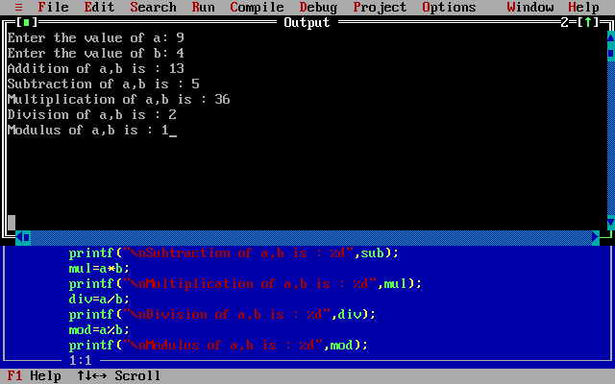

Q2.

//logical operators

#include<stdio.h>

#include<conio.h>

void main()

{

int a,b,c,d;

clrscr();

printf("Enter the values of a, b, c and d:");

printf("\na= "); scanf("%d",&a);

printf("b= "); scanf("%d",&b);

printf("c= "); scanf("%d",&c);

printf("d= "); scanf("%d",&d);

if(a>b && a>c)

printf("a is greater than b AND c (&&)");

if(b>c || b>d)

printf("\nb is greater than c OR d (||)");

if(!d)

printf("\nd is zero");

else

printf("\nd is not zero (!)");

}

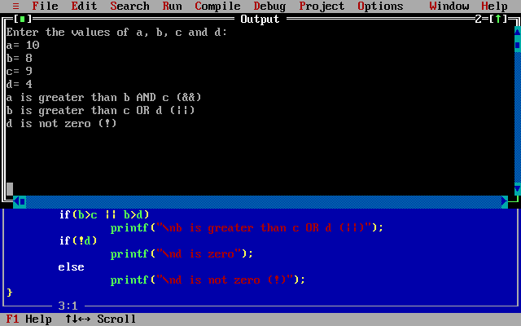

Q3.

//Relational operators

#include<stdio.h>

#include<conio.h>

void main()

{

int a,b;

clrscr();

printf("Enter the values of a and b");

printf("\na= "); scanf("%d",&a);

printf("b= "); scanf("%d",&b);

printf("1. >(greater than)");

if(a>b)

printf("\n\ta is greater than b");

else

printf("\n\ta is less than or equal to b");

printf("\n2. >=(greater than equal to)");

if(a>=b)

printf("\n\ta is greater than or equal to b");

else

printf("\n\ta is lesser than b");

printf("\n3. <(less than)");

if(a<b)

printf("\n\ta is less than b");

else

printf("\n\ta is greater than or equal to b");

printf("\n4. <=(lesser than equal to)");

if(a<=b)

printf("\n\ta is lesser than or equal to b");

else

printf("\n\ta is greater than b");

printf("\n5. ==(equal to)");

if(a==b)

printf("\n\ta is equal to b");

else

printf("\n\ta and b are not equal");

printf("\n6. !=(not equal to)");

if(a!=b)

printf("\n\ta is not equal to b");

else

printf("\n\ta is equal to b");

}

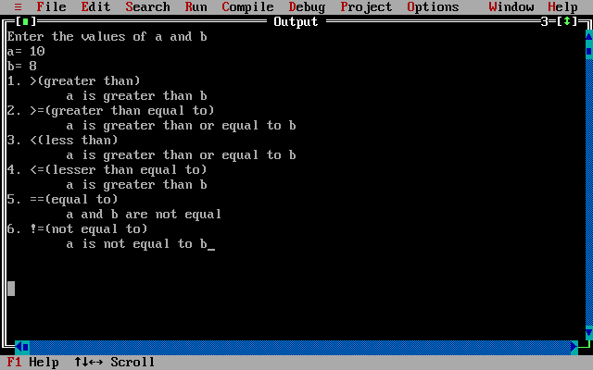

Q4.

//bitwise operators

#include<stdio.h>

#include<conio.h>

void main()

{

int a,b;

clrscr();

printf("Enter the values of a and b");

printf("\na= "); scanf("%d",&a);

printf("b= "); scanf("%d",&b);

printf("1. & (Bitwise AND)");

printf("\n\ta&b= %d",a&b);

printf("\n2. | (Bitwise OR)");

printf("\n\ta|b= %d",a|b);

printf("\n3. ^ (Bitwise XOR)");

printf("\n\ta^b= %d",a^b);

printf("\n4. ~ (Bitwise NOT)");

printf("\n\t~a= %d and ~b= %d",~a,~b);

printf("\n5. << (Left SHIFT)");

printf("\n\ta<<2= %d and b<<2= %d",a<<2,b<<2);

printf("\n6. << (Right SHIFT)");

printf("\n\ta>>2= %d and b>>2= %d",a>>2,b>>2);

}

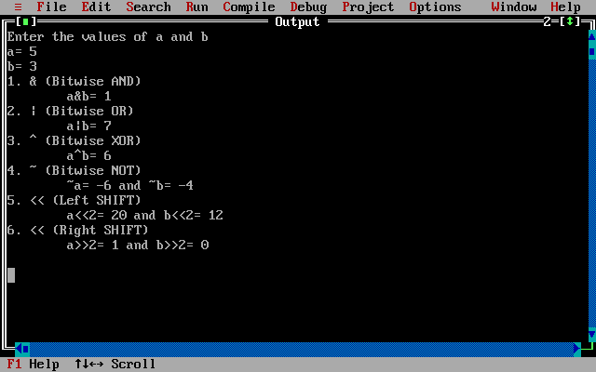

Q5.

//assignment operators

#include<stdio.h>

#include<conio.h>

void main()

{

int a,c;

clrscr();

printf("Assignment Operators");

printf("\nEnter the value of a ");

scanf("%d",&a);

printf("1. =");

c=a;

printf("\n\tc is = %d",c);

printf("\n2. +=");

c+=a; //c=c+a;

printf("\n\tc is = %d",c);

printf("\n3. -=");

c-=a; //c=c-a;

printf("\n\tc is = %d",c);

printf("\n4. *=");

c*=a; //c=c*a;

printf("\n\tc is = %d",c);

printf("\n5. /=");

c/=a; //c=c/a;

printf("\n\tc is = %d",c);

printf("\n6. %=");

c%=a; //c=c%a;

printf("\n\tc is = %d",c);

}

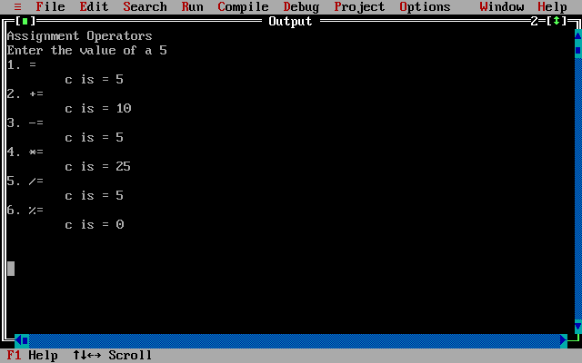

**Practical 3:**

**If Statements(if-else, Nested if-else):**

Q1.

/*WAP to accept age of a candidate, if it is less than 18 display mesage

"Driving Licence not possible", if it is equal to or greater than 18 display

message "Pls aply for a Driving Licence"?*/

#include<stdio.h>

#include<conio.h>

void main()

{

int age;

clrscr();

printf("Enter your AGE ");

scanf("%d",&age);

if(age<18)

printf("Driving Licence not possible");

else

printf("Pls aply for a Driving Licence");

}

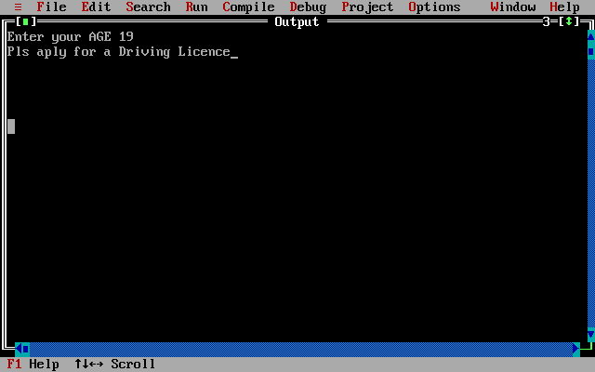

Q2.

//Q33.Write a program to find the largest of three numbers.

#include<stdio.h>

#include<conio.h>

void main()

{

int a,b,c;

clrscr();

printf("Enter the values of a,b and c");

printf("\na= "); scanf("%d",&a);

printf("b= "); scanf("%d",&b);

printf("c= "); scanf("%d",&c);

if(a>b && a>c)

printf("a is greater than b and c");

else if(b>a && b>c)

printf("b is greater than a and c");

else

printf("c is greater than a and b");

}

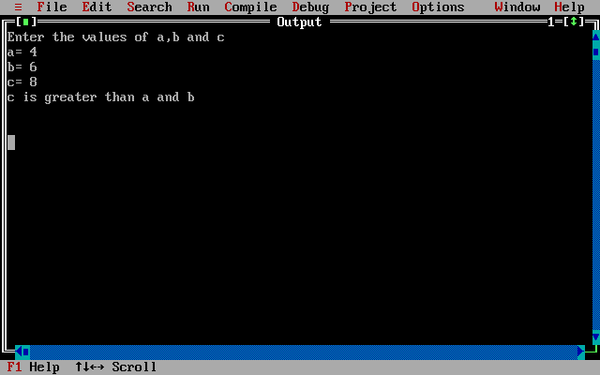

Q3.

//NESTED IF

/*WAP to check if a number is divisible by 2, if yes check also if it the

number is divisible by 3 then display the number is divisible by 6? if it is

not divisible by 2, check if it is divisible by 5, and print appropriate

message?*/

#include<stdio.h>

#include<conio.h>

void main()

{

int a;

clrscr();

printf("Enter the value of a");

scanf("%d",&a);

if(a%2==0)

{

printf("Number is divisible by 2");

if(a%3==0)

printf("\nNumber is divisible by 6");

}

else

{

printf("Number is not divisible by 2");

if(a%5==0)

printf("\nNumber is divisible by 5");

}

}

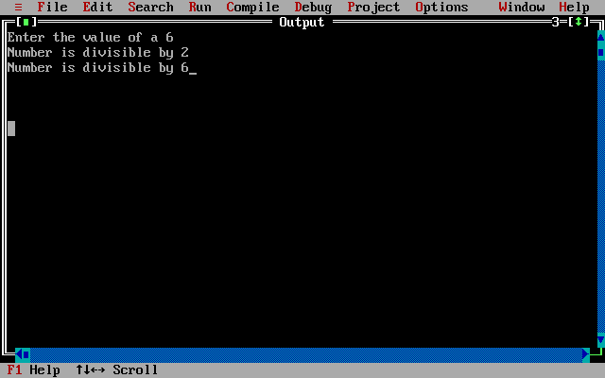

Q4.

//NESTED IF-ELSE

/*WAP to accept marks of a student and print appropriate grades according

to the following table:

Marks Grade

>90

<=90 and >75 O

<=75 and >60 A

<=60 and >50 B

<=50 and >40 C

<40 Fail*/

#include<stdio.h>

#include<conio.h>

void main()

{

int mrk;

clrscr();

printf("Enter your marks");

scanf("%d",&mrk);

if(mrk>90)

printf("Grade : O");

else

{

if(mrk<=90 && mrk>75)

printf("Grade : A");

else

{

if(mrk<=75 && mrk>60)

printf("Grade : B");

else

{

if(mrk<=60 && mrk >50)

printf("Grade : C");

else

{

if(mrk<=50 && mrk >40)

printf("Grade : D");

else

printf("Grade : Fail");

}

}

}

}

}

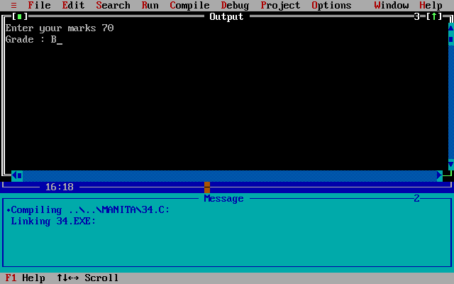

Q5.

/*WAP to display the following menu on the screen

------------MENU--------------

1.ADD

2.SUB

3.MUL

4.DIV

5.QUIT*/

#include<stdio.h>

#include<conio.h>

void main()

{

int ch,a,b;

clrscr();

printf("-------------MENU--------------");

printf("\n1.ADDITION");

printf("\n2.SUBTRACTION");

printf("\n3.MULTIPLICATION");

printf("\n4.DIVISION");

printf("\n5.QUIT");

printf("\nEnter your choice");

scanf("%d",&ch);

printf("Enter the values of a and b");

printf("\na= "); scanf("%d",&a);

printf("b= "); scanf("%d",&b);

if(ch==1)

printf("ADDITION of a and b is= %d",a+b);

if(ch==2)

printf("SUBTRACTION of a and b is= %d",a-b);

if(ch==3)

printf("MULTIPLICATION of a and b is= %d",a*b);

if(ch==4)

printf("DIVISION of a and b is= %d",a/b);

if(ch==5)

return;

}

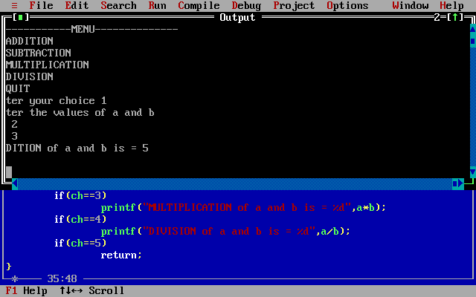

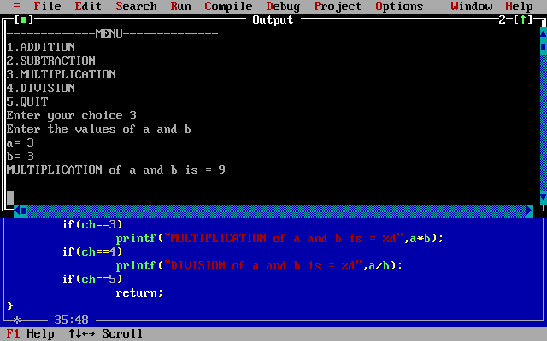

6.

/*Q62.Write a program, which accepts a character from the user and checks

if it is an alphabet, digit or puntuation symbol. If it is an alphabet,

check if it is uppercase or lowercase and then change the case?*/

#include<stdio.h>

#include<conio.h>

#include<ctype.h>

void main()

{

char ch;

clrscr();

printf("\n Enter the character ");

scanf(" %c",&ch);

if((ch>='a' && ch<='z')||(ch>='A' && ch<='Z'))

{

if(ch>='A' && ch<='Z')

{

printf("\n Character is Uppercase ");

printf("\n Character in Lowercase : %c",tolower(ch));

}

else

{

printf("\n Character is Lowercase ");

printf("\n Character in Uppercase : %c",toupper(ch));

}

}

else if(ch>='0' && ch<='9')

printf("\n Character is a digit ");

else if((ch>=58 && ch<=64)||(ch>=91 && ch<=96))

printf("\n Character is a symbol ");

}

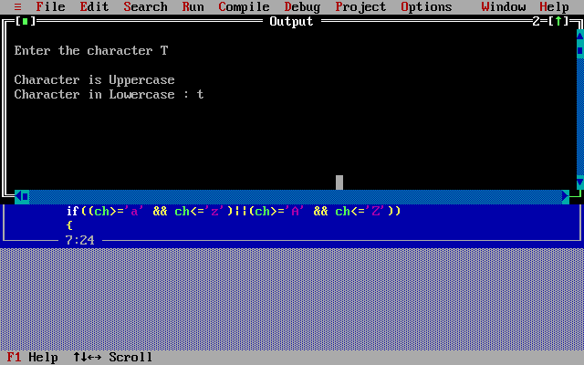

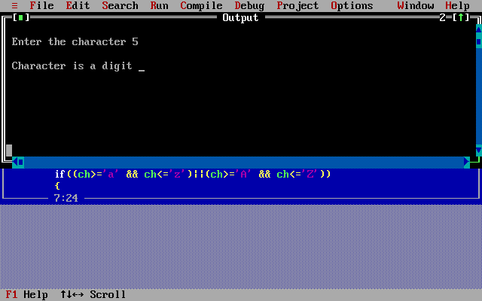

**Practical 4:**

**Switch Statements:**

Q1.

/*WAP to display the following menu on the screen

------------MENU--------------

1.ADD

2.SUB

3.MUL

4.DIV

5.QUIT*/

#include<stdio.h>

#include<conio.h>

#include<math.h>

void main()

{

int ch,a,b,p1,p2;

clrscr();

printf(" Enter the values of a and b");

printf("\n a= "); scanf("%d",&a);

printf(" b= "); scanf("%d",&b);

while(1)

{

printf("\n-------------MENU--------------");

printf("\n 1.ADDITION");

printf("\n 2.SUBTRACTION");

printf("\n 3.MULTIPLICATION");

printf("\n 4.DIVISION");

printf("\n 5.QUIT");

printf("\n Enter your choice");

scanf("%d",&ch);

switch(ch)

{

case 1:

printf(" ADDITION of a and b is= %d",a+b);

break;

case 2:

printf(" SUBTRACTION of a and b is= %d",a-b);

break;

case 3:

printf(" MULTIPLICATION of a and b is= %d",a*b);

break;

case 4:

printf(" DIVISION of a and b is= %d",a/b);

break;

case 5:

exit(0);

default:

printf(" Wrong Choice");

}

}

}

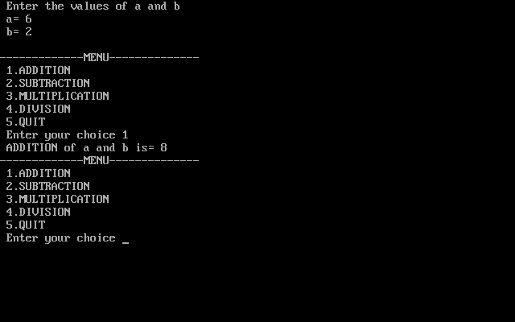

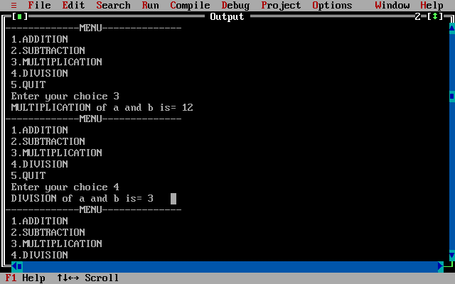

Q2.

**Practical 5:**

**Looping(Simple):**

Q1.

/*Q21.Write a c program to print the Fibonacci series up to 'n' terms.

(1,1,2,3,5,8,........n)*/

#include<stdio.h>

#include<conio.h>

void main()

{

int n,i,f1=1,f2=1,f3=0;

clrscr();

printf(" ====FIBONACCI SERIES====");

printf("\n Enter the value of n : ");

scanf("%d",&n);

printf(" First %d terms of fibinacci series are : ",n);

for(i=0;i<n;i++)

{ if(i==0||i==1)

f3=1;

else

{ f3=f2+f1;

f1=f2;

f2=f3;

}

printf(" %d",f3);

}

}

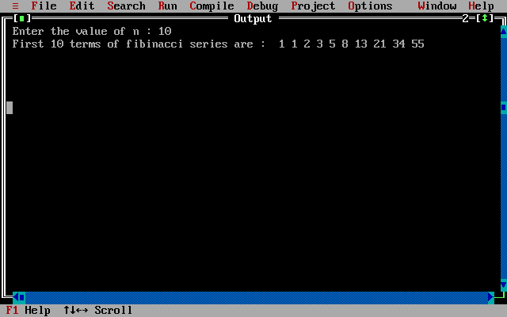

Q2.

/*Q23.Write a C program to find the sum of first 'n' even numbers.

(accept n from the user)?*/

#include<stdio.h>

#include<conio.h>

void main()

{

int i,n,s=0;

clrscr();

printf(" Enter the value of n : ");

scanf(" %d",&n);

for(i=2;i<=n;i+=2)

s=s+i;

printf(" Sum of first 'n' even numbers is : %d",s);

}

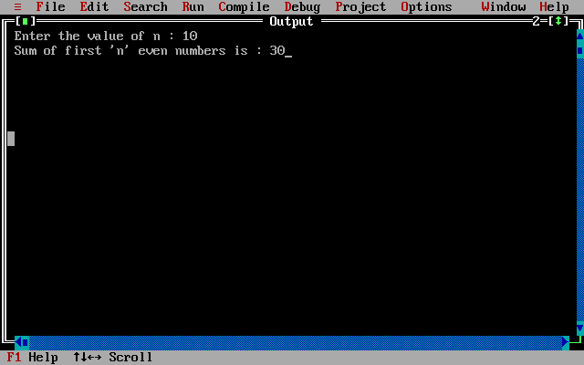

Q3.

//Q57.Write a program to accept a number and print its multiplication table?

#include<stdio.h>

#include<conio.h>

void main()

{

int n,i=1,m;

clrscr();

printf("\n =======MULTIPLICATION TABLE======= ");

printf("\n Enter a number : ");

scanf(" %d",&n);

printf(" Multiplication table of %d : \n",n);

while(i<=10)

{

m=n*i;

printf(" %d*%d = %d\n",n,i,m);

i++;

}

}

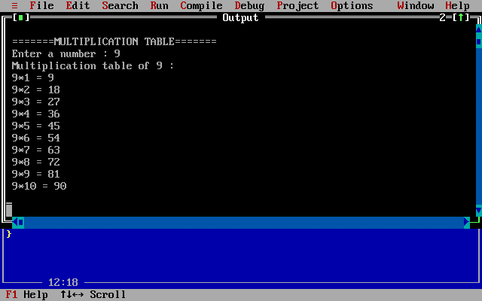

Q4.

//Q60.Write a C program to accept a number and find the sum of its digits?

#include<stdio.h>

#include<conio.h>

void main()

{

int num,sum=0,r,i=0;

clrscr();

printf(" Enter a number : ");

scanf(" %d",&num);

while(num>0)

{

r=num%10;

sum=sum+r;

num=num/10;

i++;

}

printf(" Sum of digits is : %d",sum);

}

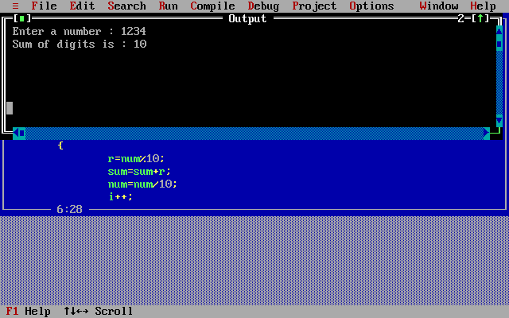

Q5.

/*Q49.Write a C program to string from the user and replace all occurrences

of character 'a' by '*' symbol?*/

#include<stdio.h>

#include<conio.h>

void main()

{

char str[20];

int i=0;

clrscr();

printf(" Enter a String ");

gets(str);

do

{

if(str[i]=='a')

str[i]='*';

i++;

}

while(str[i]!='\0');

printf(" New String : %s",str);

}

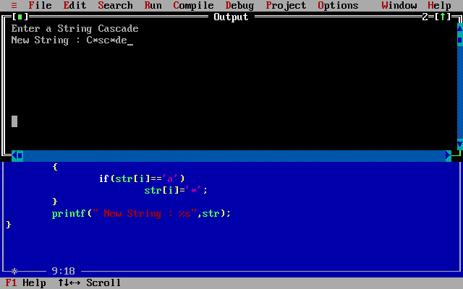6.

//WAP to print backward from n till 1?

#include<stdio.h>

#include<conio.h>

void main()

{

int n,i;

clrscr();

printf(" Enter the value of n : ");

scanf(" %d",&n);

i=n;

do

{

printf(" %d\n",i);

i--;

}while(i>=1);

}

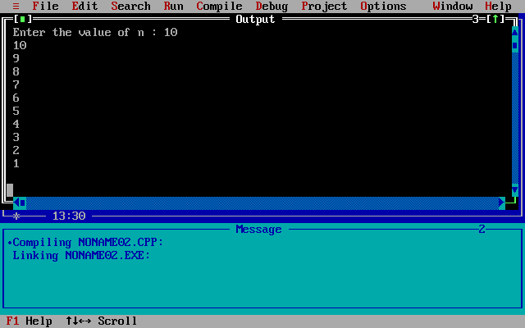

**Practical 6:**

**Looping(Pattern):**

Q1.

/*Q13.Write a C program to generate the following pattern for n lines:

Aa

Aa Bb

Aa Bb Cc

Aa Bb Cc Dd */

#include<stdio.h>

#include<conio.h>

void main()

{

int i,j,n;

char c,s;

clrscr();

printf(" Enter number of lines : ");

scanf("%d",&n);

for(i=0;i<n;i++)

{

c='A',s='a';

for(j=0;j<=i;j++)

{

printf(" %c%c ",c,s);

c++; s++;

}

printf("\n");

}

}

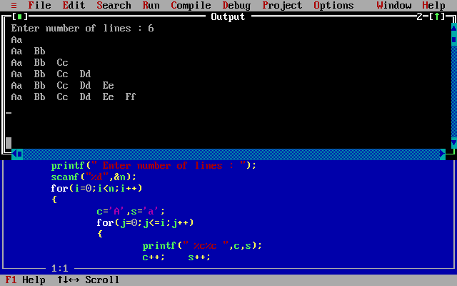

Q2.

/*Q24.Write a C program to generate the following pattern (for n lines.

Accept n from the user)?:

1 2 3 4

5 6 7

8 9

10 */

#include<stdio.h>

#include<conio.h>

void main()

{

int i,j,k=1,n;

clrscr();

printf(" Enter the values of n : ");

scanf(" %d",&n);

for(i=n;i>=0;i--)

{

for(j=0;j<i;j++)

{

printf(" %d",k);

k++;

}

printf("\n");

}

}

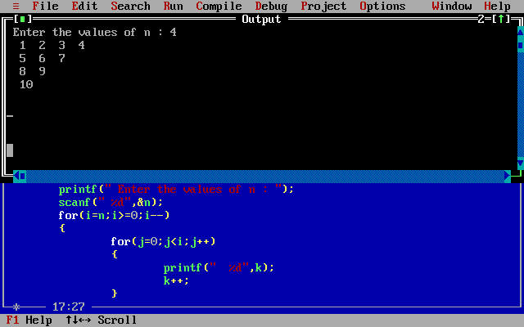

Q3.

/*Q56.Write a C program to print the following pattern for 'n' lines.

Accept 'n' from the user:

A

B B

C C C

D D D D*/

#include<stdio.h>

#include<conio.h>

void main()

{

int i=0,j,n;

char k='A';

clrscr();

printf(" Enter the value of n : ");

scanf(" %d",&n);

while(i<n)

{ j=0;

while(j<=i)

{

printf(" %c",k);

j++;

}

printf("\n");

k++;

i++;

}

}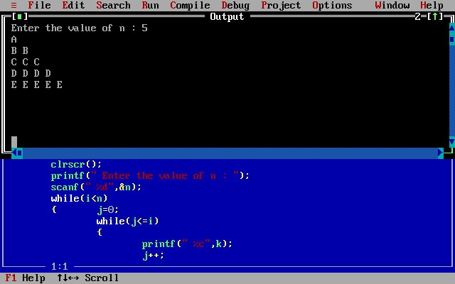

Q4.

/*Q66.Write a program to generate the following pattern for n lines.Accept

'n' from the user:

1

12

123

1234

123

12

1*/

#include<stdio.h>

#include<conio.h>

void main()

{

int i=0,j,n;

clrscr();

printf(" Enter the value of n : ");

scanf(" %d",&n);

while(i<=n)

{

j=1;

while(j<i)

{

printf(" %d",j);

j++;

}

printf("\n");

i++;

}

i=n-1;

while(i>0)

{

j=1;

while(j<i)

{

printf(" %d",j);

j++;

}

printf("\n");

i--;

}

}

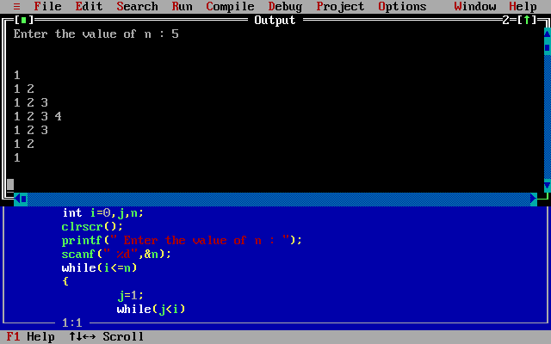

Q5.

//Q70.Write a C program to print the Floyd's triangle(for 'n' from the user(?

#include<stdio.h>

#include<conio.h>

void main()

{

int i=1,j,n,k=1;

clrscr();

printf(" Enter the value of n : ");

scanf(" %d",&n);

do

{

j=1;

do

{

printf(" %d",k);

k++;

j++;

}while(j<=i);

printf("\n");

i++;

}while(i<=n);

}

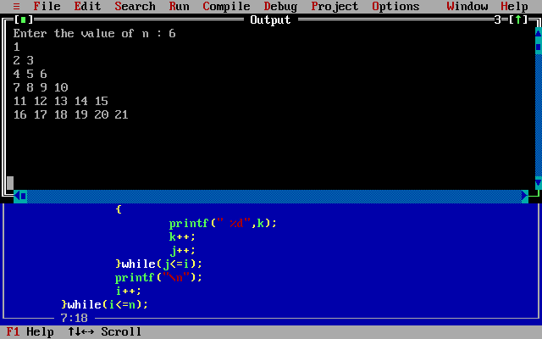

Q6.

/*Q17.Write a program to accept a string and print the following pattern

(e.g. input is string "abcd")

a

ab

abc

abcd

abc

ab

a*/

#include<stdio.h>

#include<conio.h>

#include<string.h>

void main()

{

char str[10];

int i=0,j,len;

clrscr();

printf(" Enter the string : ");

gets(str);

len=strlen(str);

do

{

j=0;

do

{

printf(" %c",str[j]);

j++;

}while(j<=i);

printf("\n");

i++;

}while(i<len);

i=len-1;

do

{

j=0;

do

{

printf(" %c",str[j]);

j++;

}while(j<i);

printf("\n");

i--;

}while(i>=0);

}

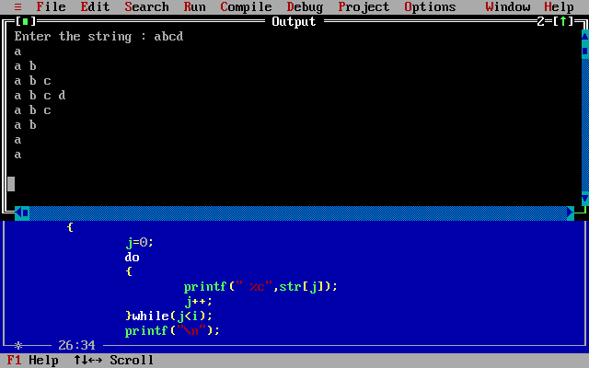

**Practical 7:**

**Arrays:**

Q1.

/*Q4.WAP to accept an array of 10 numbers.Find the minimum and

maximum numbers?*/

#include<stdio.h>

#include<conio.h>

void main()

{

int a[10],i,j,g,l;

clrscr();

printf("To find the maximum and minimum numbers");

printf("\nEnter the elements of the array");

for(i=0;i<10;i++)

scanf("%d",&a[i]);

g=a[0];

l=a[0];

for(i=0;i<10;i++)

{

for(j=0;j<10;j++)

{

if(a[j]>g)

g=a[j];

if(a[j]<l)

l=a[j];

}

}

printf("Maximum : %d",g);

printf("\nMinimum : %d",l);

}

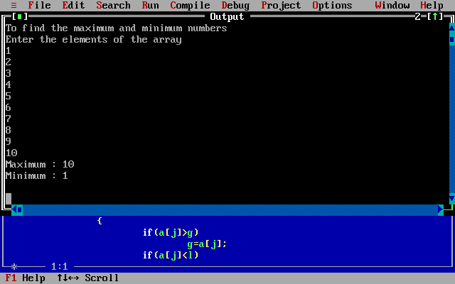

Q2.

/*Q39.Write a program to accept 2 arrays of 5 numbers each and merge

them into a third array*/

#include<stdio.h>

#include<conio.h>

void main()

{

int a1[5],a2[5],a3[10],i,j;

clrscr();

printf(" Enter the elements of the first array ");

for(i=0;i<5;i++)

scanf(" %d",&a1[i]);

printf(" Enter the elements of the second array ");

for(i=0;i<5;i++)

scanf(" %d",&a2[i]);

for(i=0;i<5;i++)

a3[i]=a1[i];

for(i=5,j=0;i<10;i++,j++)

a3[i]=a2[j];

printf(" Elements of the new merged array :");

for(i=0;i<10;i++)

{

printf(" %d",a3[i]);

}

}

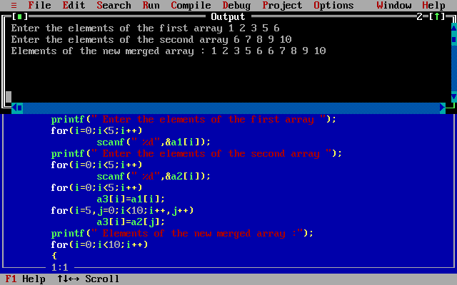

Q3.

/*Q40.Write a C program to accept 10 numbers from the user. Find the number

of positive, negative and zeroes entered?*/

#include<stdio.h>

#include<conio.h>

void main()

{

int arr[10],cp=0,cn=0,cz=0,i,j;

clrscr();

printf(" Enter 10 elements ");

for(i=0;i<10;i++)

{

scanf(" %d",&arr[i]);

if(arr[i]==0)

cz++;

else if(arr[i]<0)

cn++;

else

cp++;

}

printf(" Number of zeroes entered : %d",cz);

printf("\n Number of negative numbers entered : %d",cn);

printf("\n Number of positive numbers entered : %d",cp);

}

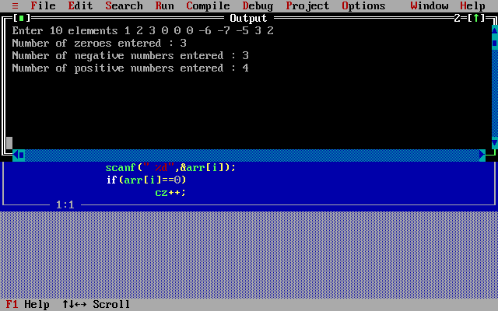

Q4.

/*Q28.Write a C program to add two matrices and display the sum in third

matrix?*/

#include<stdio.h>

#include<conio.h>

void main()

{

int m1[10][10],m2[10][10],m3[10][10],i,j,r,c;

clrscr();

printf(" Enter the no of rows and columns of matrix 1 and 2 :");

printf("\n row = "); scanf("%d",&r);

printf(" column = "); scanf("%d",&c);

printf(" Enter the elements of the matrix 1 : \n");

for(i=0;i<r;i++)

{

printf(" Enter the elements of the %dth row ",i+1);

for(j=0;j<c;j++)

scanf("%d",&m1[i][j]);

}

printf("\n Enter the elements of the matrix 2 : \n");

for(i=0;i<r;i++)

{

printf(" Enter the elements of the %dth row ",i+1);

for(j=0;j<c;j++)

scanf("%d",&m2[i][j]);

}

for(i=0;i<r;i++)

{

for(j=0;j<c;j++)

m3[i][j]=m1[i][j]+m2[i][j];

}

printf(" Sum of two matrix m1 and m2 is m3 :\n");

for(i=0;i<r;i++)

{

for(j=0;j<c;j++)

printf(" %d\t",m3[i][j]);

printf("\n");

}

}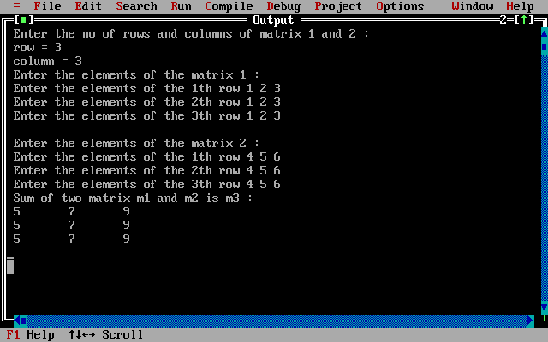

Q5.

/*Q31.Write a program to accept an m*m matrix from user and find the sum of its:

-Diagonal elements

-Non-daigonal elements*/

#include<stdio.h>

#include<conio.h>

void main()

{

int m[10][10],i,j,r,s1=0,s2=0,s3=0;

clrscr();

printf(" Enter the no of rows and columns of matrix :");

printf("\n row and columns are : "); scanf("%d",&r);

printf(" Enter the elements of the matrix : \n");

for(i=0;i<r;i++)

{

printf(" Enter the elements of the %dth row ",i+1);

for(j=0;j<r;j++)

scanf("%d",&m[i][j]);

}

for(i=0;i<r;i++)

{

for(j=0;j<r;j++)

{

if(i==j)

s1=s1+m[i][j];

if(i==(r-j-1))

s2=s2+m[i][j];

else if(1&&(i!=j))

s3=s3+m[i][j];

}

}

printf("\n Sum of left diagonal elements : %d",s1);

printf("\n Sum of right diagonal elements : %d",s2);

printf("\n Sum of Non-Diagonal elements : %d",s3);

}

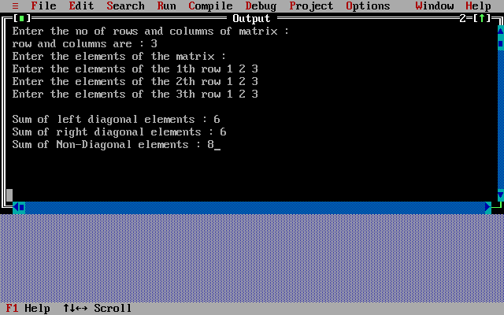

Q6.

//Q50.Write a program to accept a matrix and find its transpose?

#include<stdio.h>

#include<conio.h>

void main()

{

int m[10][10],transp[10][10],i,j,k,r,c;

clrscr();

printf(" Enter the no of rows and columns of matrix :");

printf("\n row = "); scanf("%d",&r);

printf(" column = "); scanf("%d",&c);

printf(" Enter the elements of the matrix : \n");

for(i=0;i<r;i++)

{

printf(" Enter the elements of the %dth row ",i+1);

for(j=0;j<c;j++)

scanf("%d",&m[i][j]);

}

for(i=0;i<r;i++)

{

for(j=0;j<c;j++)

transp[j][i]=m[i][j];

}

printf("\n Transpose of a matrix :\n");

for(i=0;i<c;i++)

{

for(j=0;j<r;j++)

printf(" %d\t",transp[i][j]);

printf("\n");

}

}

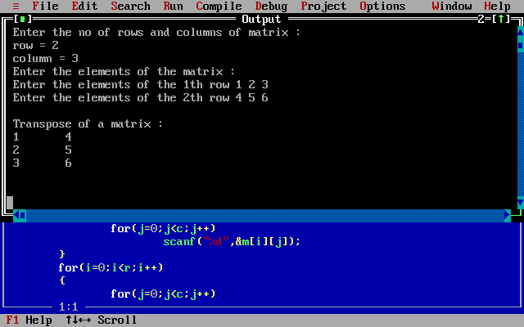

Q7.

//Q47.Write a C program for multiplication of two m*n matrices?.

#include<stdio.h>

#include<conio.h>

void main()

{

int m1[10][10],m2[10][10],m3[10][10],i,j,k,r1,c1,r2,c2;

clrscr();

printf(" Enter the no of rows and columns of matrix 1 :");

printf("\n row = "); scanf("%d",&r1);

printf(" column = "); scanf("%d",&c1);

printf(" Enter the elements of the matrix 1 : \n");

for(i=0;i<r1;i++)

{

printf(" Enter the elements of the %dth row ",i+1);

for(j=0;j<c1;j++)

scanf("%d",&m1[i][j]);

}

printf(" Enter the no of rows and columns of matrix 2 :");

printf("\n row = "); scanf("%d",&r2);

printf(" column = "); scanf("%d",&c2);

printf(" Enter the elements of the matrix 2 : \n");

for(i=0;i<r2;i++)

{

printf(" Enter the elements of the %dth row ",i+1);

for(j=0;j<c2;j++)

scanf("%d",&m2[i][j]);

}

if(c1==r2)

{

printf("\n Matrix multiplication is possible ");

for(i=0;i<r1;i++)

{

for(j=0;j<c2;j++)

{

for(k=0;k<r1;k++)

m3[i][j]=m1[i][k]*m2[k][j];

}

}

}

printf("\n Multiplication of two matrix m1 and m2 is m3 :\n");

for(i=0;i<r1;i++)

{

for(j=0;j<c2;j++)

printf(" %d\t",m3[i][j]);

printf("\n");

}

}

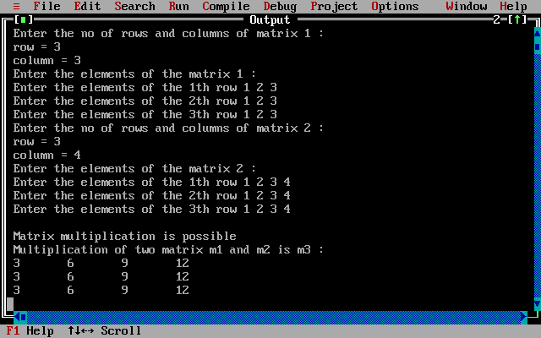

**Practical 8:**

**Strings:**

Q1.

/*Q15.Write a C program to search for a word in a string. If found print

"Found" else print "Not Found"?*/

#include<stdio.h>

#include<conio.h>

#include<string.h>

void main()

{

char str[30],word[10];

clrscr();

printf(" Enter a string : ");

gets(str);

printf(" Enter a word : ");

gets(word);

if(strstr(str,word)!=0)

printf(" Found");

else

printf(" Not Found");

}

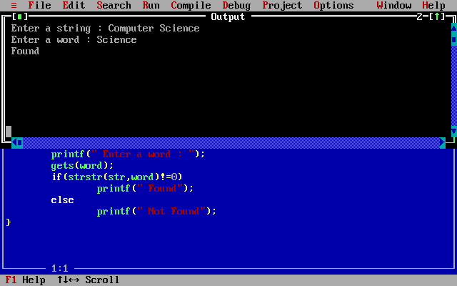

Q2.

/*Q18.Write a C program to accept a string from user, delete all vowels from

that string and display the result?*/

#include<stdio.h>

#include<conio.h>

void main()

{

char s[20],s1[20];

int i=0,j=0;

clrscr();

printf(" Enter a string : ");

gets(s);

while(s[i]!='\0')

{

if(s[i]=='a'||s[i]=='e'||s[i]=='i'||s[i]=='o'||s[i]=='u'

||s[i]=='A'||s[i]=='E'||s[i]=='I'||s[i]=='O'||s[i]=='U');

else

s1[j++]=s[i];

i++;

}

s1[j]='\0';

printf(" New string after the deletion of vowels : %s",s1);

}

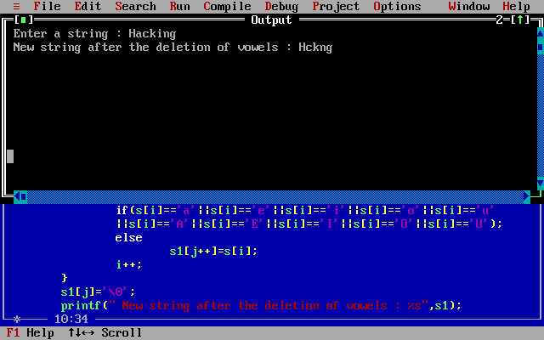

Q3.

/*Q26.Write a C program to accept a tring from the user and calculate the

length without using standard library functions*/

#include<stdio.h>

#include<conio.h>

void main()

{

int i;

char str[20];

clrscr();

printf(" Enter a string to find its length : ");

gets(str);

for(i=0;str[i]!='\0';i++);

printf(" Length : %d",i);

}

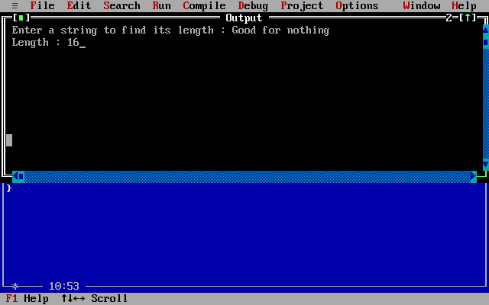

Q4.

/*Q29.Write a program to concatenate two strings without standard library

functions?*/

#include<stdio.h>

#include<conio.h>

void main()

{

char str1[20],str2[20];

clrscr();

printf(" Enter string 1 ");

gets(str1);

printf(" Enter string 2 ");

gets(str2);

printf(" New String : %s%s",str1,str2);

}

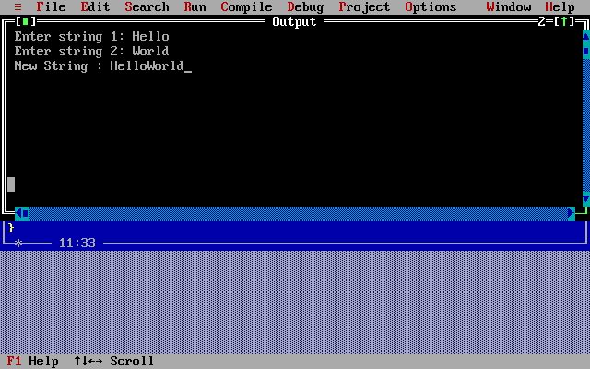

Q5.

/*Q64.Write a C program to accept a string from user, delete all consonants

from that string and display the result?*/

#include<stdio.h>

#include<conio.h>

void main()

{

char s[10],s1[10];

int i=0,j=0;

clrscr();

printf(" Enter a string ");

gets(s);

while(s[i]!='\0')

{

if(s[i]=='a'||s[i]=='e'||s[i]=='i'||s[i]=='o'||s[i]=='u'

||s[i]=='A'||s[i]=='E'||s[i]=='I'||s[i]=='O'||s[i]=='U')

s1[j++]=s[i];

i++;

}

s1[j]='\0';

printf(" New string after the deletion of vowels : %s",s1);

}

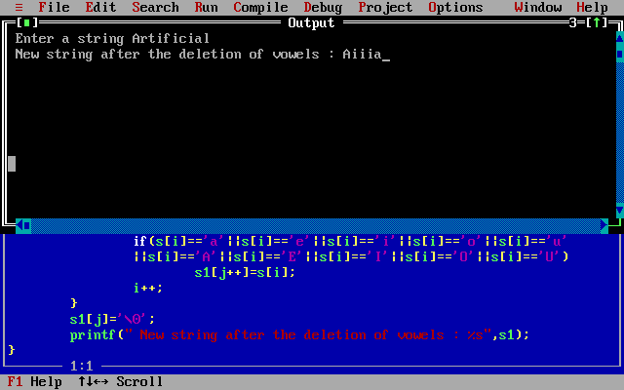

**Practical 9:**

**String Functions:**

Q1.

/*Q37.Write a C program to accept a character from the user.Print its ASCII value.

Print the next and previous character*/

#include<stdio.h>

#include<conio.h>

void main()

{

char c;

clrscr();

printf(" Enter a character ");

scanf(" %c",&c);

printf(" ASCII value of %c is : %d",c,c);

printf("\n Previous character : %c",c-1);

printf("\n Next character : %c",c+1);

}

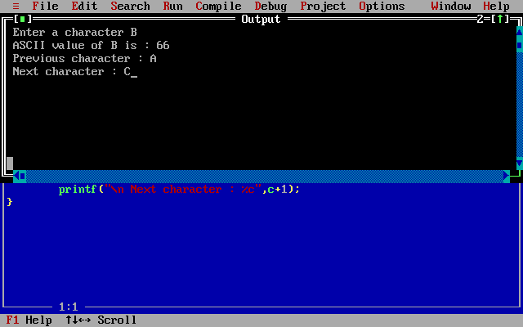

Q2.

//Q51.Write a C program to accept a sentence from user and reverse its each word?

#include<stdio.h>

#include<conio.h>

#include<string.h>

void main()

{

int i,j;

char msg[20],str[20];

clrscr();

printf(" Enter a Sentence : ");

gets(msg);

for(i=0,j=0;msg[i]!='\0';i++)

{

if(msg[i]!=' ')

{

str[j]=msg[i];

j++;

}

else

{

str[j]='\0';

printf(" %s",strrev(str));

printf(" ");

j=0;

}

}

str[j]='\0';

printf("%s",strrev(str));

}

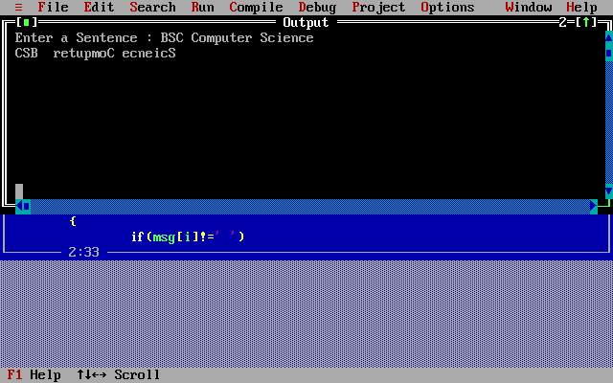

Q3.

//Q53.Write a C program to convert a given string into uppercase and viceversa?

#include<stdio.h>

#include<conio.h>

#include<string.h>

void main()

{

char str[20];

int i;

clrscr();

printf(" Enter a String : ");

gets(str);

for(i=0;str[i]!='\0';i++)

{

if(str[i]>='A' && str[i]<='Z')

str[i]=str[i]+32;

}

printf(" Converted String in Lowercase : %s",str);

for(i=0;str[i]!='\0';i++)

{

if(str[i]>='a' && str[i]<='z')

str[i]=str[i]-32;

}

printf("\n Converted String in Uppercase : %s",str);

}

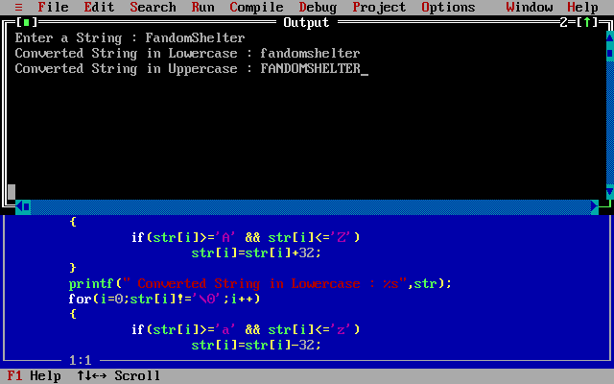

Q4.

/*Q58.Write a C program to accept two strings str1 and str2 and compare them.

If they are equal display their length*/

#include<stdio.h>

#include<conio.h>

#include<string.h>

void main()

{

char str1[20],str2[20];

int i,j,l;

clrscr();

printf(" Enter String1 : ");

gets(str1);

printf(" Enter String2 : ");

gets(str2);

if(strcmp(str1,str2)==0)

{

printf(" Strings are equal ");

l=strlen(str1);

printf("\n Length of String1 and String2 is %d",l);

}

else if(strcmp(str1,str2)>0)

printf(" String1 is greater than String2 ");

else

printf(" String2 is greater than String1 ");

}

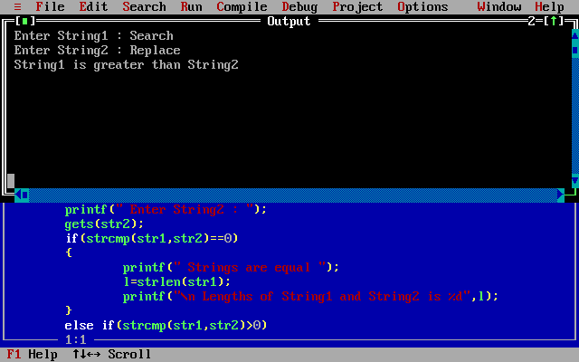

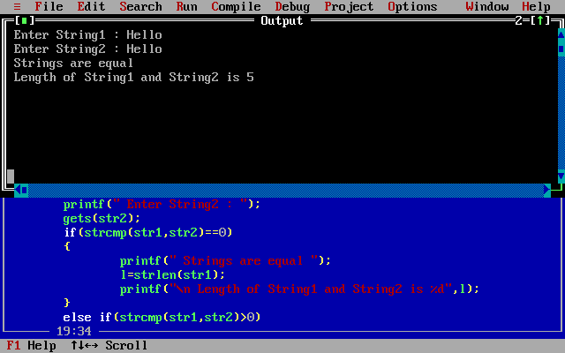

Q5.

/*Q68.Write a C program to accept two strings and concatenate them using

standard library function*/

#include<stdio.h>

#include<conio.h>

#include<string.h>

void main()

{

char str1[10],str2[10];

int i,j;

clrscr();

printf(" Enter String1 : ");

gets(str1);

printf(" Enter String2 : ");

gets(str2);

strcat(str1,str2);

printf(" New String : %s",str1);

}

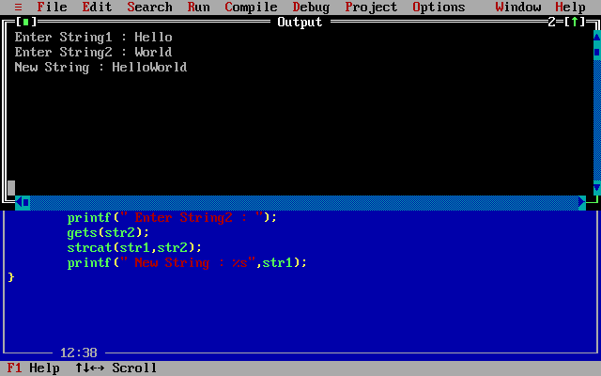

Q.6

/*Q61.Write a C program to accept two strings str1 and str2 and compare them.

If they are equal display their length, if str1>str2,convert str2 to uppercase

and str2 to lowercase and display the strings and vice versa*/

#include<stdio.h>

#include<conio.h>

#include<string.h>

void main()

{

char str1[20],str2[20];

int i,j,l;

clrscr();

printf("\n Enter String1 : ");

gets(str1);

printf(" Enter String2 : ");

gets(str2);

if(strcmp(str1,str2)==0)

{

printf(" Strings are equal ");

l=strlen(str1);

printf("\n Lengths of String1 and String2 is %d",l);

}

else if(strcmp(str1,str2)>0)

{

printf(" String1 is greater than String2 ");

printf("\n String1 in Uppercase : %s",strupr(str1));

printf("\n String2 in Lowercase : %s",strlwr(str2));

}

else

{

printf(" String2 is greater than String1 ");

printf("\n String1 in Lowercase : %s",strlwr(str1));

printf("\n String2 in Uppercase : %s",strupr(str2));

}

}

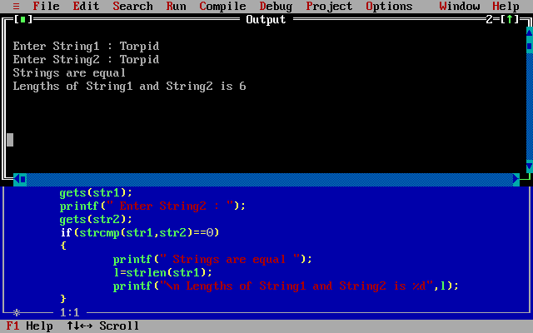

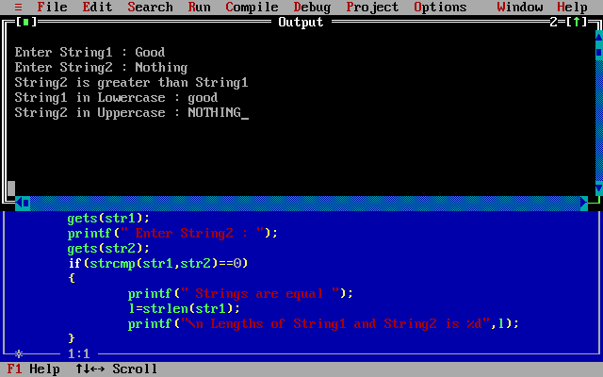

8.

/*Q69.Write a program, which accepts a character from the user and checks

if it is an alphabet, digit or puntuation symbol. If it is an alphabet,

check if it is uppercase or lowercase and then change the case?*/

#include<stdio.h>

#include<conio.h>

#include<ctype.h>

void main()

{

char ch;

clrscr();

printf("\n Enter the character ");

scanf(" %c",&ch);

if((ch>='a' && ch<='z')||(ch>='A' && ch<='Z'))

{

printf(" It is an Alphabet \n");

if(ch>='A' && ch<='Z')

{

printf("\n Character is Uppercase ");

printf("\n Character in Lowercase : %c",tolower(ch));

}

else

{

printf("\n Character is Lowercase ");

printf("\n Character in Uppercase : %c",toupper(ch));

}

}

else if(ch>='0' && ch<='9')

printf("\n Character is a digit ");

else if((ch>=58 && ch<=64)||(ch>=91 && ch<=96))

printf("\n Character is a symbol ");

}

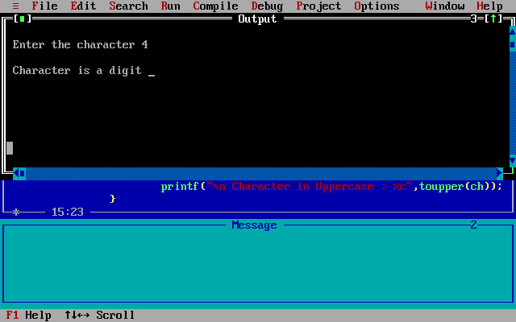

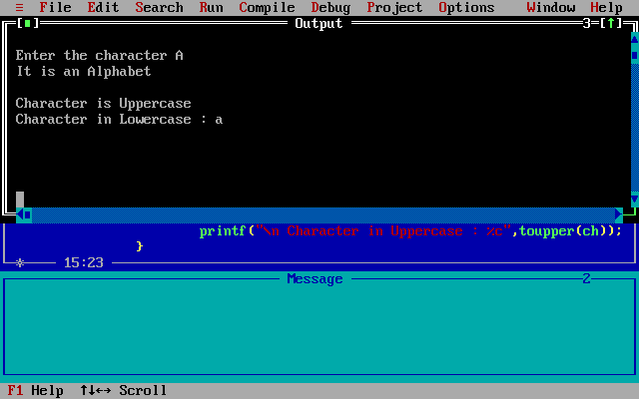

**Practical 10:**

**Functions:**

Q1.

//Q55.Write a program to accept a number and convert it into binary?

#include<stdio.h>

#include<conio.h>

void binary(int);

void main()

{

int n;

clrscr();

printf(" Enter the number : ");

scanf(" %d",&n);

binary(n);

}

void binary(int n)

{

int i,arr[10];

for(i=0;n>0;i++)

{

arr[i]=n%2;

n=n/2;

}

printf(" Equivalent Decimal no is : ");

for(i=i-1;i>=0;i--)

printf("%d",arr[i]);

}

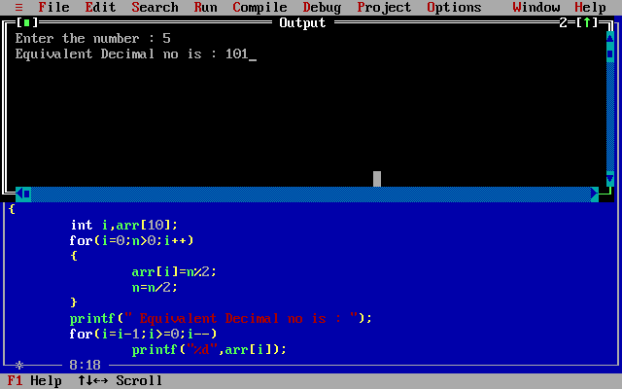

Q2.

//Q44.Write a C program to check whether a number is perfect.

#include<stdio.h>

#include<conio.h>

void perf(int);

void main()

{

int num;

clrscr();

printf(" Enter a Number : ");

scanf(" %d",&num);

perf(num);

}

void perf(int n)

{

int r,s=0,i;

for(i=1;i<=n-1;i++)

{

r=n%i;

if(r==0)

s=s+i;

}

if(s==n)

printf(" It is a Perfect Number");

else

printf(" Not a Perfect Number");

}

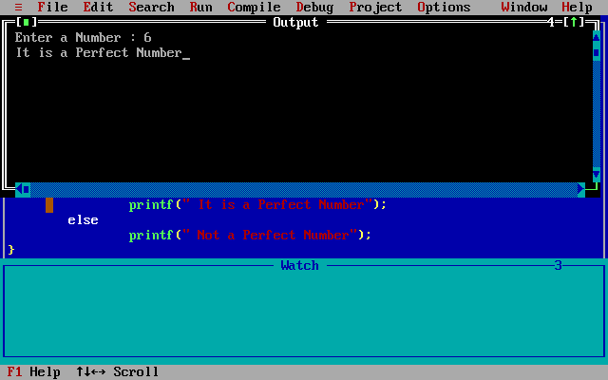

Q5.

//Q46.Write a program to accept a string and check if its a palindrome?

#include<stdio.h>

#include<conio.h>

#include<string.h>

int palindrome(char[]);

void main()

{

char str[10];

int f;

clrscr();

printf(" Enter the string ");

scanf(" %s",&str);

f=palindrome(str);

if(f==0)

printf(" It is a Palindrome ");

else

printf(" It is not a Palindrome ");

}

int palindrome(char str[])

{

int l,i,f=0;

l=strlen(str);

for(i=0;i<=l;i++)

{

if(str[i]!=str[l-1-i])

f=1;

break;

}

return f;

}

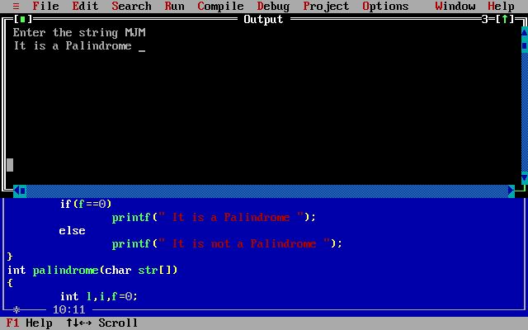

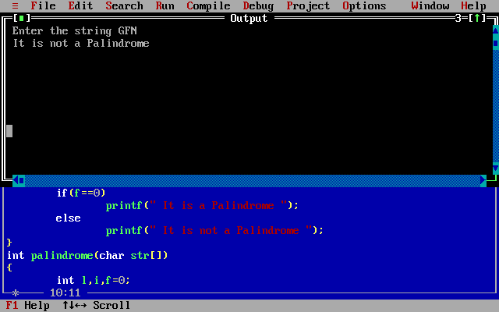

Q3.

/*Q32.Write a library program in C which performs the following operations

on strings. Write seperate function for each option:

==========MENU============

A.Check if one string is substring of another string.

B.Count number of occurrences of a character in the string.

C.Exit*/

#include<stdio.h>

#include<conio.h>

#include<string.h>

#include<process.h>

void substr();

void occurr();

void main()

{

char ch;

clrscr();

while(1)

{

printf("\n ==========MENU===========");

printf("\n A.Check if one string is substring of another string");

printf("\n B.Count number of occurrences of a character in the string");

printf("\n C:Exit\n");

printf("\n Enter the choice ");

scanf("%c",&ch);

switch(ch)

{

case 'A':

substr();

break;

case 'B':

occurr();

break;

case 'C':

exit(0);

}

}

}

void substr()

{

char str1[10],str2[10];

printf(" Enter String1 ");

scanf("%s",&str1);

printf(" Enter String2 ");

scanf("%s",&str2);

if(strstr(str1,str2)!=0)

printf(" String2 is a substring of String1 \n");

else

printf(" String2 is a substring of String1 \n");

}

void occurr()

{

int i,count=0;

char c,str[10];

printf(" Enter String : ");

scanf(" %s",&str);

printf(" Enter a character : ");

scanf(" %c",&c);

for(i=0;str[i]!='\0';i++)

{

if(str[i]==c)

count++;

}

printf(" Number of occurrence of %c is : %d",c,count);

}

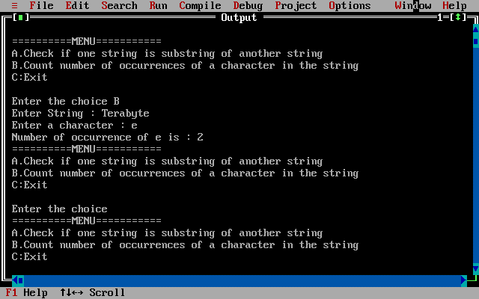

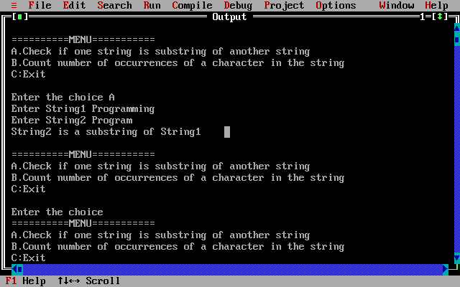

Q4.

/*Q22.Write a C program to perform the following operations on strings

using user defined functiond?

1.Calculate length of string.

2.Copy one string to another.*/

#include<stdio.h>

#include<conio.h>

#include<process.h>

void calclen();

void copystr();

void main()

{

int ch;

while(1)

{

printf("\n\n ==========MENU==========");

printf("\n 1:Calculate length of string");

printf("\n 2:Copy one string to another");

printf("\n 3.EXIT");

printf("\n Enter your choice ");

scanf(" %d",&ch);

switch(ch)

{

case 1:

calclen();

break;

case 2:

copystr();

break;

case 3:

exit(0);

}

}

}

void calclen()

{

int i;

char str[20];

printf(" Enter a string to find its length ");

scanf(" %s",&str);

for(i=0;str[i]!='\0';i++);

printf(" Length : %d",i);

}

void copystr()

{

int i;

char str1[20],str2[20];

printf(" Enter a string : ");

scanf(" %s",&str1);

for(i=0;str1[i]!='\0';i++)

str2[i]=str1[i];

str2[i]='\0';

printf(" New string %s ",str2);

}

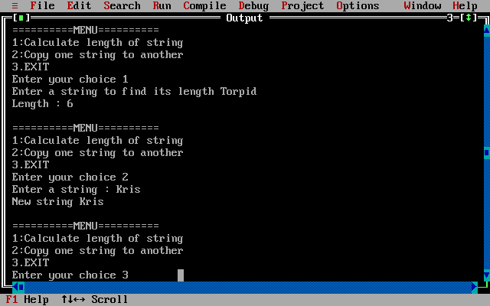

**Practical 11:**

**Recursion:**

Q1.

/*Q5.WAP to find factorial of a number using recursion?*/

#include<stdio.h>

#include<conio.h>

int fact(int);

void main()

{

int n,f;

clrscr();

printf("To find factorial of a number using recursion");

printf("\nEnter a value : ");

scanf("%d",&n);

if(n<0)

printf(" Factoriall of a negative number doesn't exist");

else

f=fact(n);

printf("Factorial of %d is : %d",n,f);

}

int fact(int n)

{

if(n==0||n==1)

return 1;

else

return(n*(fact(n-1)));

}

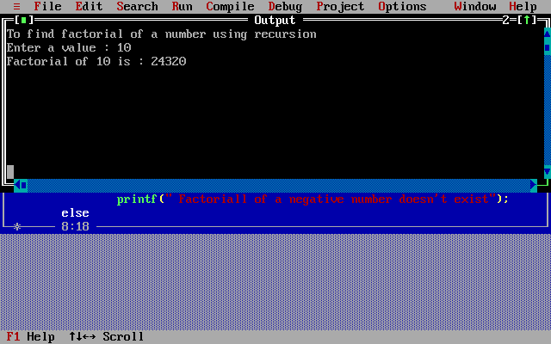

**Practical 12:**

**Pointers:**

Q1.

/*Q2.WACP to swap the values of two variables by using call by reference?*/

#include<stdio.h>

#include<conio.h>

void swap(int *,int *);

void main()

{

int a,b;

clrscr();

printf("Call by Reference");

printf("\nEnter the values of a and b");

printf("\na = "); scanf("%d",&a);

printf("b = "); scanf("%d",&b);

printf("Values of a and b before swapping in main function: %d, %d",a,b);

swap(&a,&b);

printf("\nValues of a and b after swapping in main function: %d, %d",a,b);

}

void swap(int *a,int *b)

{

int temp=*a;

*a=*b;

*b=temp;

printf("\nValues of a and b after swapping in swap function: %d, %d",*a,*b);

}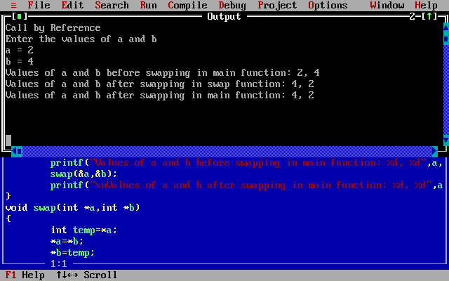

2.

//WAP to accept a string from the user and diplsay one character at a time?

#include<stdio.h>

#include<conio.h>

void main()

{

char str[10];

int i;

clrscr();

printf(" Enter your name : ");

scanf(" %s",str);

for(i=0;str[i]!='\0';i++)

{

printf(" %c\n",str[i]);

}

}

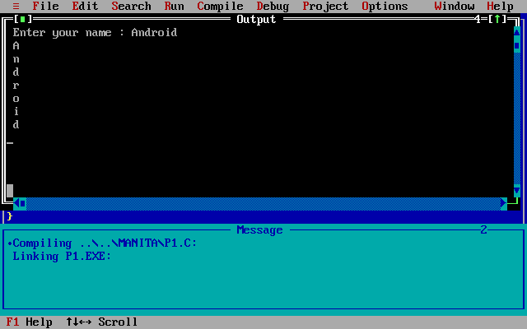

**Practical 13:**

**Dynamic Allocation:**

Q1.

/*Q35.Write a C program to accept the name and marks of 3 subjects for 'n'

students and print the grade based on the table given below.

Per<35 Grade="Fail"

Per>=35 & Per<50 Grade="Pass"

Per>=50 & Per<55 Grade="Second Class"

Per>=55 & Per<60 Grade="Higher Second Class"

Per>=60 & Per<75 Grade="First Class"

Per>=75 Grade="Distinction"*/

#include<stdio.h>

#include<conio.h>

#include<alloc.h>

#include<string.h>

struct stud{

char name[20];

int m1,m2,m3;

int per;

char Grade[20];

}*s;

void main()

{

int n,i;

clrscr();

printf(" Enter number of students : ");

scanf(" %d",&n);

s=(struct stud*)malloc(n*sizeof(struct stud));

printf(" Enter details of %d studennts : ",n);

for(i=0;i<n;i++)

{

printf("\n Enter name : ");

scanf("%s",&(s+i)->name);

printf(" Enter marks1 : ");

scanf("%d",&(s+i)->m1);

printf(" Enter marks2 : ");

scanf("%d",&(s+i)->m2);

printf(" Enter marks2 : ");

scanf("%d",&(s+i)->m3);

}

for(i=0;i<n;i++)

{

(s+i)->per=(((s+i)->m1)+((s+i)->m2)+((s+i)->m3))/3.0;

if((s+i)->per<35)

strcpy((s+i)->Grade,"Fail");

else if((s+i)->per>=35 && (s+i)->per<50)

strcpy((s+i)->Grade,"Pass");

else if((s+i)->per>=50 && (s+i)->per<55)

strcpy((s+i)->Grade,"Second Class");

else if((s+i)->per>=55 && (s+i)->per<60)

strcpy((s+i)->Grade,"Higher Second Class");

else if((s+i)->per>=60 && (s+i)->per<75)

strcpy((s+i)->Grade,"First Class");

else

strcpy((s+i)->Grade,"Distinction");

}

for(i=0;i<n;i++)

{

printf("\n Student name : %s",(s+i)->name);

printf("\n Grade : %s",(s+i)->Grade);

}

}

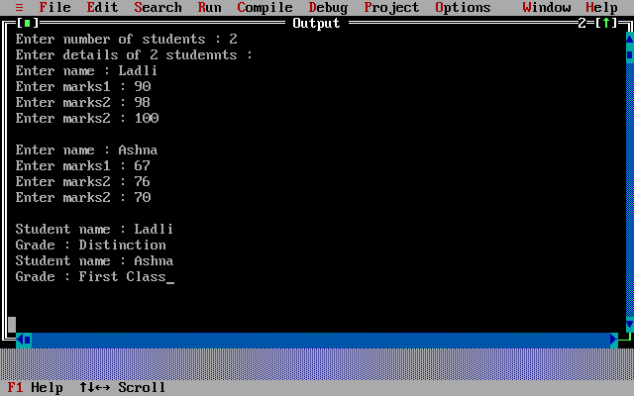

Q2.

/*Q30.Write a C program to accept 'n' numbers from user, store these numbers

into an array and count the number occurrence of each number

[dynmaic allocation]?*/

#include<stdio.h>

#include<conio.h>

#include<alloc.h>

void main()

{

int *p,*f,n,i,j,l;

clrscr();

printf(" To count frequency of each element of an array");

printf("\n Enter the size of the array : ");

scanf(" %d",&n);

p=(int*) malloc(n*sizeof(int));

f=(int*) malloc(n*sizeof(int));

printf(" Enter the elements : ");

for(i=0;i<n;i++)

{

scanf(" %d",(p+i));

*(f+i)=-1;

}

for(i=0;i<n;i++)

{

l=0;

for(j=0;j<n;j++)

{

if(*(p+i)==*(p+j))

{

l++;

*(f+j)=0;

}

}

if((f+j)!=0)

*(f+i)=l;

}

printf(" Frequency of all elements of array : \n");

for(i=0;i<n;i++)

{

if(*(f+i)!=0)

printf(" %d occurs %d times\n",*(p+i),*(f+i));

}

}

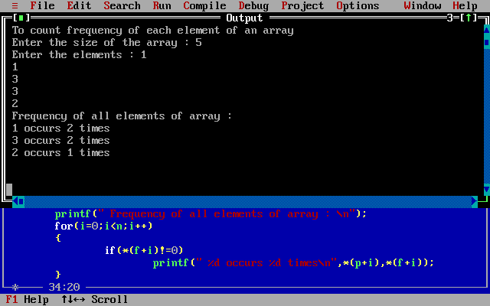

Q3.

**Practical 14:**

**Structures & Unions:**

Q1.

/*Q6.Write a menu driven program in 'C' that shows the working of a library,

The menu options include:

==========MENU============

-Add book information

-Display book information

-List all books of given number

-List the count of books in the library

-Exit*/

#include<stdio.h>

#include<conio.h>

#include<string.h>

void add_book();

void disp_book();

void book_auth();

void count_book();

struct lib

{

int acc_no;

char book_title[20];

char author[20];

int cost;

}b[10];

int count;

void main()

{

int ch;

clrscr();

while(1)

{

printf("\n==========MENU===========\n");

printf("\n 1:Add book information\n");

printf("\n 2:Display book information\n");

printf("\n 3:List all the books of given author\n");

printf("\n 4:List the count of books in the library\n");

printf("\n 5:Exit\n");

printf("\n Enter the choice ");

scanf("%d",&ch);

switch(ch)

{

case 1:

add_book();

break;

case 2:

disp_book();

break;

case 3:

book_auth();

break;

case 4:

count_book();

break;

case 5:

exit(0);

}

}

}

void add_book()

{

int i,add;

printf(" How many records you want to add ");

scanf("%d",&add);

for(i=count;i<add;i++)

{

if(count==9)

{

printf("\n No more space");

return;

}

printf(" Enter the details of the book ");

printf("\n Enter accession number =");

scanf("%d",&b[i].acc_no);

printf(" Enter the book title=");

scanf("%s",&b[i].book_title);

printf(" Enter the author name =");

scanf("%s",&b[i].author);

printf(" Enter the cost of book=");

scanf("%d",&b[i].cost);

count++;

}

}

void disp_book()

{

int i;

printf("\n Details of %d books in library",count);

for(i=0;i<count;i++)

{

printf("\n Accession number = %d",b[i].acc_no);

printf("\n Title of the book = %s",b[i].book_title);

printf("\n Author name = %s",b[i].author);

printf("\n Cost of book= %d",b[i].cost);

}

}

void book_auth()

{

int i,cnt=0;

char name[20];

printf("\n Enter the author name = ");

scanf("%s",&name);

for(i=0;i<count;i++)

{

if(strcmp(name,b[i].author)==0)

{

printf("\n Accession number = %d",b[i].acc_no);

printf("\n Title of the book = %s",b[i].book_title);

printf("\n Author name = %s",b[i].author);

printf("\n Cost of book = %d",b[i].cost);

cnt++;

}

}

if(cnt==0)

printf("\n No such book \n");

}

void count_book()

{

printf(" Total no of books in library =%d\n",count);

}

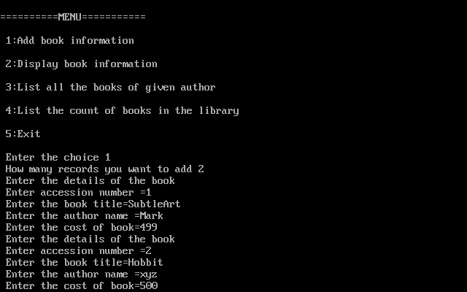

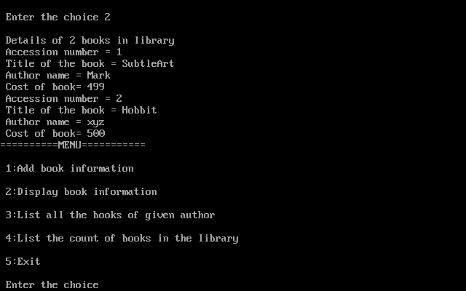

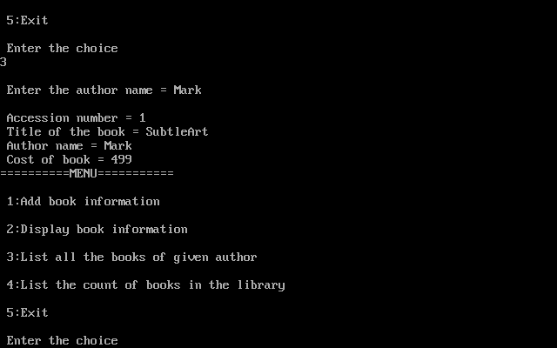

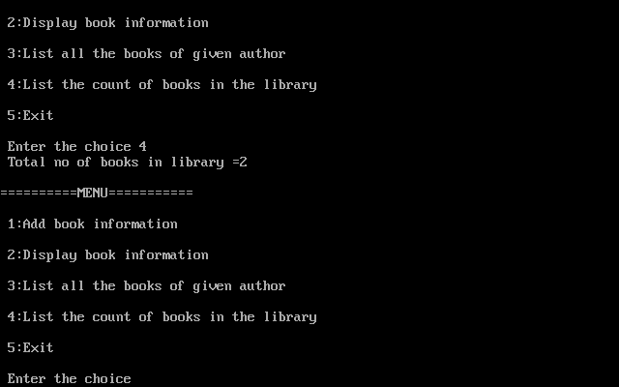

Q2.

/*Q27.Write a C program to accept student information(roll_no, name and

percentage of marks for n students. Display them in alphabetical order of

their name?*/

#include<stdio.h>

#include<conio.h>

void add_sinfo();

void display();

struct student

{

int roll_no;

char name[20];

int percentage;

}s[10];

int count=0;

void main()

{

int ch;

clrscr();

while(1)

{

printf("\n==========MENU===========\n");

printf("\n 1:Add Students information\n");

printf("\n 2:Display Students information\n");

printf("\n 3:Exit\n");

printf("\n Enter the choice ");

scanf("%d",&ch);

switch(ch)

{

case 1:

add_sinfo();

break;

case 2:

display();

break;

case 3:

exit(0);

}

}

}

void add_sinfo()

{

int i,add,j;

printf(" How many Students records you want to add ");

scanf("%d",&add);

for(i=count;i<add;i++)

{

if(count==9)

{

printf("\n No more space");

return;

}

printf(" Enter the details of the student ");

printf("\n Enter roll number = ");

scanf("%d",&s[i].roll_no);

printf(" Enter Student name = ");

scanf("%s",&s[i].name);

printf(" Enter Percentage = ");

scanf("%d",&s[i].percentage);

count++;

}

}

void display()

{

char temp[10];

int i,j,t1,t2;

for(i=0;i<count;i++)

{

for(j=i+1;j<count;j++)

{

if(strcmp(s[i].name,s[j].name)>0)

{

strcpy(temp,s[i].name);

strcpy(s[i].name,s[j].name);

strcpy(s[j].name,temp);

t1=s[i].roll_no;

s[i].roll_no=s[j].roll_no;

s[j].roll_no=t1;

t2=s[i].percentage;

s[i].percentage=s[j].percentage;

s[i].percentage=t2;

}

}

}

printf(" Students information sorted in alphabetical order of their names ");

for(i=0;i<count;i++)

{

printf("\n Roll no: %d",s[i].roll_no);

printf("\n Student name = %s",s[i].name);

printf("\n Percentage = %d\n",s[i].percentage);

}

}

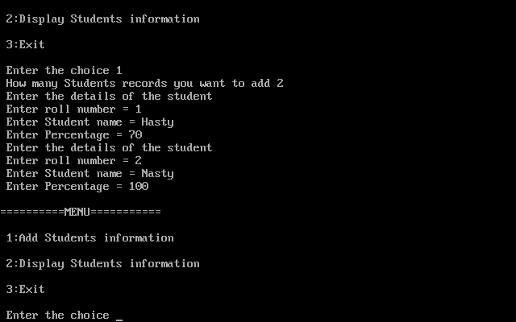

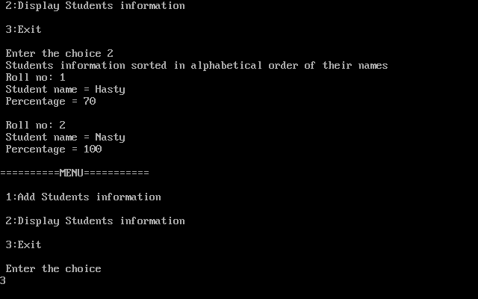

Q3.

/*Q43.Write a C program to accept customer details such as Account_no, Name,

Balance in account. Assume Maximum 20 customers in the bank. Write a

function to print the account no and name of each customer?*/

#include<stdio.h>

#include<conio.h>

void add_cinfo();

void display();

struct customer

{

int account_no;

char name[20];

int balance;

}c[20];

int count;

void main()

{

int ch;

clrscr();

while(1)

{

printf("\n==========MENU===========\n");

printf("\n 1:Add Customer information\n");

printf("\n 2:Display Customer informations\n");

printf("\n 3:Exit\n");

printf("\n Enter the choice ");

scanf("%d",&ch);

switch(ch)

{

case 1:

add_cinfo();

break;

case 2:

display();

break;

case 3:

exit(0);

}

}

}

void add_cinfo()

{

int i,add;

printf(" How many records you want to add ");

scanf("%d",&add);

for(i=count;i<add;i++)

{

if(count==19)

{

printf("\n No more space");

return;

}

printf(" Enter the details of the customer ");

printf("\n Enter account number = ");

scanf("%d",&c[i].account_no);

printf(" Enter Customer name = ");

scanf("%s",&c[i].name);

printf(" Enter Balance in account = ");

scanf("%d",&c[i].balance);

count++;

}

}

void display()

{

int i;

for(i=0;i<count;i++)

{

printf("\n Account number = %d",c[i].account_no);

printf("\n Customer name = %s\n",c[i].name);

}

if(count==0)

printf("\n No Customer \n");

}

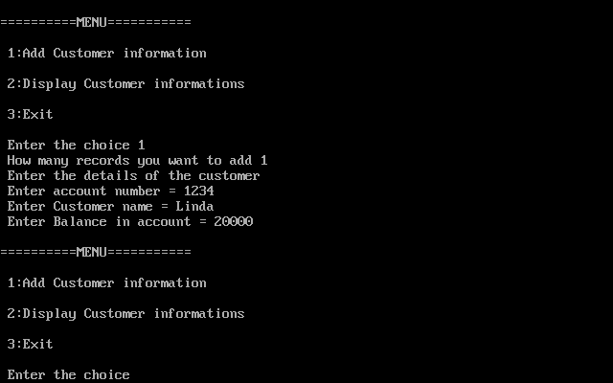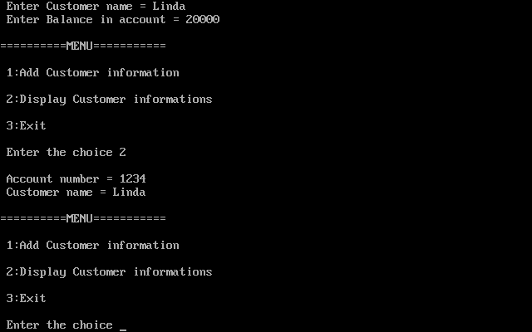

Q4.

/*Q45.Write a C program to accept the information of fie employees(emp_no,

emp_name, emp_salary) using structures and print this informationn?*/

#include<stdio.h>

#include<conio.h>

void add_einfo();

void display();

struct employee

{

int emp_no;

char emp_name[20];

int emp_salary;

}e[20];

int count;

void main()

{

int ch;

while(1)

{

printf("\n==========MENU===========\n");

printf("\n 1:Add Employee information\n");

printf("\n 2:Display Employee informations\n");

printf("\n 3:Exit\n");

printf("\n Enter the choice ");

scanf("%d",&ch);

switch(ch)

{

case 1:

add_einfo();

break;

case 2:

display();

break;

case 3:

exit(0);

}

}

}

void add_einfo()

{

int i,add;

printf(" How many records you want to add ");

scanf("%d",&add);

for(i=count;i<add;i++)

{

if(count==19)

{

printf("\n No more space");

return;

}

printf(" Enter the details of the Employee ");

printf("\n Enter employee number = ");

scanf("%d",&e[i].emp_no);

printf(" Enter employee name = ");

scanf("%s",&e[i].emp_name);

printf(" Enter Salary = ");

scanf("%d",&e[i].emp_salary);

count++;

}

}

void display()

{

int i;

for(i=0;i<count;i++)

{

printf("\n Employee number = %d",e[i].emp_no);

printf("\n Employee name = %s\n",e[i].emp_name);

printf("\n Salary = %d",e[i].emp_salary);

}

if(count==0)

printf("\n No Customer \n");

}

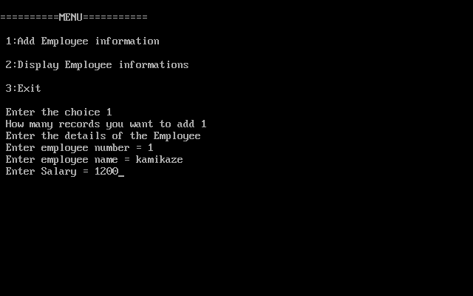

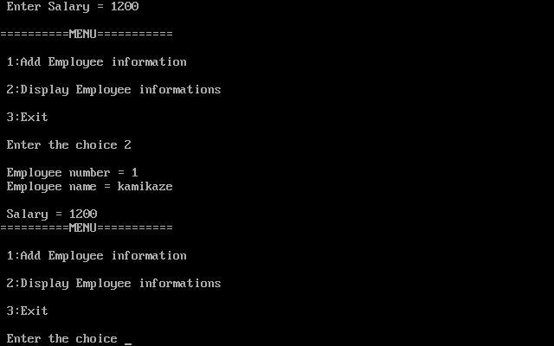

5.

/*Q11.Write a C program to accept customer details such as: Account_no, Name,

Balance in account. Assume Maximum 20 customers in the bank. Write a function

to print the account no and name of each customer with Balance below Rs.100?*/

#include<stdio.h>

#include<conio.h>

void add_cinfo();

void calc();

struct customer

{

int account_no;

char name[20];

int balance;

}c[20];

int count;

void main()

{

int ch;

clrscr();

while(1)

{

printf("\n==========MENU===========\n");

printf("\n 1:Add customer information\n");

printf("\n 2:Display Customers with Balance below Rs.100\n");

printf("\n 3:Exit\n");

printf("\n Enter the choice ");

scanf("%d",&ch);

switch(ch)

{

case 1:

add_cinfo();

break;

case 2:

calc();

break;

case 3:

exit(0);

}

}

}

void add_cinfo()

{

int i,add;

printf(" How many records you want to add ");

scanf("%d",&add);

for(i=count;i<add;i++)

{

if(count==19)

{

printf("\n No more space");

return;

}

printf(" Enter the details of the customer ");

printf("\n Enter account number = ");

scanf("%d",&c[i].account_no);

printf(" Enter Customer name = ");

scanf("%s",&c[i].name);

printf(" Enter Balance in account = ");

scanf("%d",&c[i].balance);

count++;

}

}

void calc()

{

int i,cnt=0;

for(i=0;i<count;i++)

{

if(c[i].balance<=100)

{

printf("\n Account number = %d",c[i].account_no);

printf("\n Customer name = %s\n",c[i].name);

cnt++;

}

}

if(cnt==0)

printf("\n No such Customer \n");

}

